Level 1/2 Introductory Welding Skills
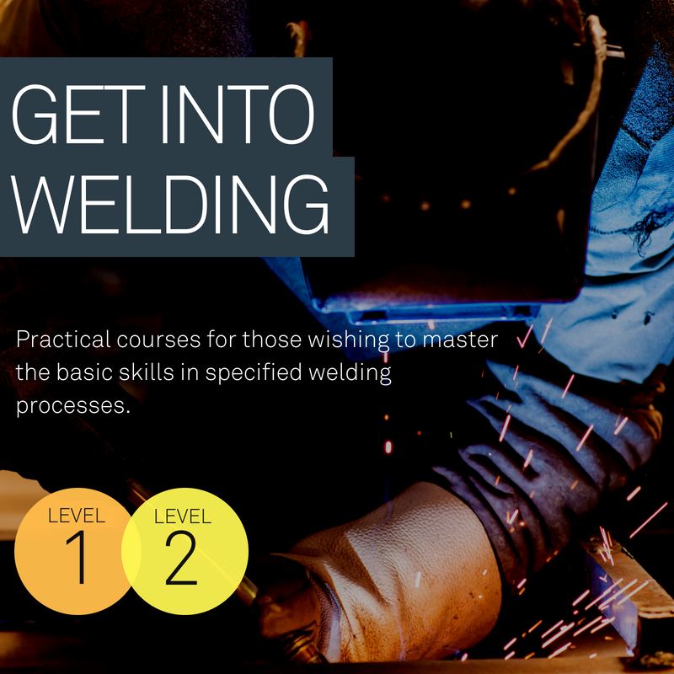
Days: Monday, Tuesday or Wednesday
Evenings 5pm - 8pm

Length: The course length is dependent on prior experience and ability, but as a guide each level takes around ten weeks to complete.
Cost: Fully Funded (subject to eligibility)

Summary

These welding courses aim to give the learner introductory skills in Tungsten Inert Gas (TIG), Metal Inert Gas (MIG) and Manual Metal Arc (MMA) welding.

The Level 1 course will suit anyone new to welding, whilst the Level 2 course allows the candidate to build on the skills acquired in the Level 1 course.
What are the entry requirements?
There are no previous qualifications, learning or experience entry requirements for the Level 1 course.
Candidates must have a Level 1 welding qualification to be eligible for the Level 2 course.

What qualification will I achieve?
Successful delegates will receive:-
Level 1 Certificate in Introductory Welding Skills
Level 1 Award in Introductory Tungsten Inert Gas Welding
Level 2 Certificate in Welding Skills
Level 2 Award in Welding Skills

What subjects will I study?
The learner will train in Level 1 and 2 techniques in the following methods.
MMA – Manual Metal Arc Welding, this is the most flexible and one of the most widely used arc welding processes. It involves striking an arc between a covered metal electrode and a workpiece.
TIG – Tungsten Inert Gas Welding, this uses a non-consumable tungsten electrode to produce the weld. The weld area and electrode is protected from oxidation by an inert shielding gas.
MIG – Metal Inert Gas Welding, this is a welding process in which an electric arc forms between a consumable wire electrode and the workpiece metal, which heats the workpiece metal causing them to melt and join.
Students will learn the basic welding techniques and be able to read basic engineering drawings related to the welding industry.
How will I learn?
The course is a highly practical course, delivered in our workshop using state of the art equipment. The course content includes the under-pinning knowledge of welding techniques and also covers health and safety. All lessons are practical although a small amount of reading and internet research is advisable to answer the oral questions at the end of the course.

How will I be assessed?

The learner will complete five practical tests together with oral questioning. These will be assessed in accordance with City and Guilds predetermined criteria which will include both visual and destructive testing.
What opportunities will this lead to?
Once the learner has achieved the pass standard at Level 2 they have the opportunity to apply for the TWI4872 accreditation for each technique, for a small cost.
How long is the course?
The length of the course is dependent on the learner’s previous welding experience and ability. As a guide it is estimated to take ten weeks for each level.

