Level 2 Certificate in Falls Prevention Awareness
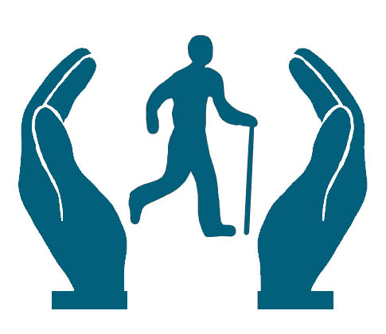
Delivery: Distance Learning – Study at a time and place convenient to yourself, with no need to attend college.

Length: 12 Weeks

Cost: Fully Funded (subject to eligibility)

Summary

Falls prevention training courses can be very beneficial for individuals looking to pursue a career in the health and social care sector. This qualification aims to provide learners with a deeper understanding of falls and how to prevent them. This qualification is aimed at anyone working in a healthcare or social care environment, particularly those that support or have contact with older people who have an increased propensity to falls. This includes individuals working in hospitals, care homes or helping to care for individuals living in their own home.
What are the entry requirements?
There are no previous qualifications, learning or experience entry requirements for this course.

What qualification will I achieve?
Successful delegates will receive the Level 2 Certificate in Falls Prevention Awareness.

What subjects will I study?
The course is split into four manageable units:

Unit 1: Falls in context
Unit 2: The risk factors and causes of falls
Unit 3: Falls assessment and prevention
Unit 4: Managing falls

How will I learn?
The course is delivered through the distance learning model, meaning you can study at a time and place convenient to yourself. You can choose between online learning with online assessment or paper based learning materials and paper based assessment.

How will I be assessed?

The learner will be assessed throughout their study by a series of assessment questions which are built into the course. The learner will submit their answers to a trained tutor for marking, who will provide robust feedback on each question. This tutor will also provide support and guidance throughout the course.
What opportunities will this lead to?
Upon completion of the Falls Prevention training, learners can progress on to a Level 3 course.
How long is the course?
The course takes 12 weeks to complete.

