AQA A-Level
PSYCHOLOGY















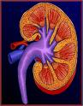

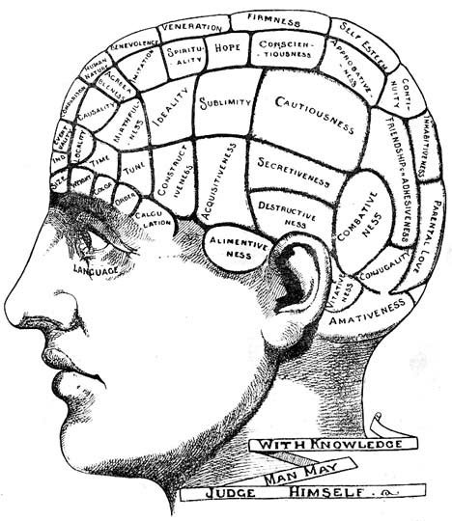




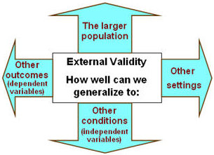



A-LEVEL
PSYCHOLOGY (AQA)

.


Paper 1: Introductory Topics in Psychology
We will cover the topics of:

1. Social Influence:
Where we will look at different types of conformity as well as explanations for conformity. We will also look at different explanations for obedience as well as variables affecting obedience. We will finish by looking at why some people can resist the pressure to obey.

2. Memory
Here we will cover two main models of human memory: The multi-store model of memory and the working memory model.
We will also look at explanations for forgetting and factors affecting the accuracy of eyewitness testimony. We will then apply this to police work to see how such research can be used to improve the accuracy of eyewitness testimony.

3. Attachment
This topic investigates caregiver-infant interactions in humans including stages of attachment and multiple attachments including the role of the father. We will also cover animal studies of attachment and explanations of attachment.


4. Psychopathology
This topic focuses on mental health & disorders, including definitions of abnormality.
We will then move onto the behavioural, emotional and cognitive characteristics of phobias, depression and OCD (obsessive compulsive disorder).
We will analyse the cognitive approach to explaining and treating depression as well as the behavioural approach to explaining and treating phobias.
We will finish the topic by looking at the biological approach to explaining and treating OCD.


Paper 2: Psychology in Context

We will cover the topics of:

1. Approaches in Psychology
This general topic focuses on the origins of Psychology and the emergence of Psychology as a science.
It then moves on to look at the basic assumptions of three main approaches: Behaviourism, Social Learning Theory, Biological and Cognitive, (including the emergence of cognitive neuroscience)

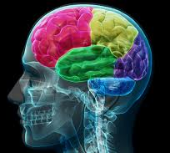

Biopsychology
The purpose of this topic is for students to understand the biological processes that underpin behaviour. This includes the structure and function of the nervous system; the function of the endocrine system; and the flight or fight response.


- Research Methods
This general topic focuses on the ways in which psychologists carry out research into behaviour. This involves you looking at the different methods used; the issues surrounding these methods; as well as how to analyses and present data from such research. As well as classroom content this topic will also involve you carrying out and analysing your own, small-scale, practical research activities

Paper 3: Issues & Debates & Options

Paper 3 you will learn about:

- Issues and debates in Psychology
- One option from: relationships; gender; cognition and development
- One from schizophrenia; eating behaviour; stress
- One from aggression; forensic psychology; addiction

All 3 papers are sat at the end of the second year. Each exam paper is 2hrs long.

Useful Resources for A-LEVEL YEAR 1

AQA Psychology for A Level Year 1 & AS - Student Book (2nd Edition) by Cara Flanagan, Dave Berry, Matt Jarvis, Illuminate publishing ISBN 978-1908682406 – Available from the 7th May 2020


The Complete Companions: AQA Psychology Year 1 and AS Student Book (Fourth Edition) by Mike Cardwell and Cara Flanagan, OUP Oxford Publishing, ISBN 978-0198338642



The Research Methods Companion for A Level Psychology Second
Edition by Cara Flanagan, OUP Oxford publishing, ISBN 978-0-19-835613-4

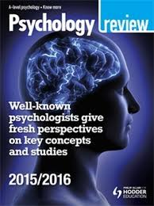
Psychology Review

Websites

AQA Psychology homepage: http://www.aqa.org.uk/subjects/psychology/as-and-a-level/psychology-7181-7182

https://simplypsychology.org/

British Psychological Society https://www.bps.org.uk/

Research Digest

What kind of psychologist might you be?
Tick the answer which apply to you: A, B, C, or D

- When recruiting participants for your experiment would you:
- Give them all the information you can and explain it in detail
- Give them a consent form to sign and then probably forget about it in all the business
- Don’t give them a consent form because you need to deceive them (it’s for the greater good after all!)
- Take absolute delight in deceiving your participants, what’s the point of knowing how people’s minds work if you can’t use it to your advantage huh?!

- When you design your experiment would you:
- Try to avoid any research where there might be ethical issues.
- Recruit students, sixth formers, and people who are easy to find
- Know that deception is part of your field of work but make sure everyone is looked after well and has counselling if they need it
- Deception is essential in psychology research, and besides, it’s entertaining!

- Would you tell people at the outset that they have a right to withdraw from the experiment at any time?
- Yes, I absolutely make it clear every single time
- I try to, but sometimes I get lost in my work and forget these things
- Not if it would ruin my experiment
- I try to, but if I can do it by tricking them into doing my bidding, then all the better!

- Would you keep people’s details confidential?
- Yes, always because human rights are important as is the data protection act
- They are nameless, but I included details of their experiences in my writing, and on documentaries, and it is all done in the name of science and not for me!
- Yes, but there are still photos around, you can’t keep a lid on everything!
- Well usually the people I do my experiments on are pretty extrovert anyway so it’s not an issue. They know what they’re signing up for!

- Would you protect your participants from physical or psychological harm?
- I try very hard to do no harm
- Most of them, but sometimes to make an omelette you’ve got to break some eggs!
- Yes, everyone would be debriefed and have counsellors on standby just in case.
- Again…if they agree to be a part of my research then they know what they sign up for! But I will make sure I have counsellors available if need be, I’m not a complete monster!

Now add up your A, B, C, and D totals to find out which psychologist you are…
A | B | C | D

What kind of psychologist might you be?


MOSTLY A
You are most likely going to be like Professor Elizabeth Loftus. Elizabeth works on making Eyewitness Testimony better so that only the right people go to Prison. Her experiments show that Eyewitnesses are not very good at remembering details when under stress. She is a very professional and rigorous in ensuring that her methods are scientific and credible which is good practice for any aspiring psychologist!


MOSTLY B
You are most like Professor Philip Zimbardo. He did the famous Stanford Prison Experiment to show how social roles change behaviour. He got so carried away with the experiment he lost sight of the effects on participants until his girlfriend, also a psychologist stepped in and stopped him. He is one of the main reasons, along with Milgram (below) that the British and American Psychological Societies had to draw up ethical guidelines for research! However, Dr Zimbardo is everywhere on the net so he did rather well out of it all, check out his website “prisonexp.org” and his book “The Lucifer Effect”.


MOSTLY C
You are most like Stanley Milgram. His parents were Jewish Refugees during the war. He watched the trial of Adolph Eichmann whose defence for atrocities toward Jews was “I was only obeying orders” He set up an experiment to test this. He had to deceive participants but was uncomfortable about it. He has given us valuable understanding of human behaviour that still resonates to this day, but, he is one of the main reasons, along with Zimbardo that the British and American Psychological Societies had to draw up ethical guidelines for research!


MOSTLY D
You would be most like Derren Brown. You are not really a ‘proper’ psychologist, but you know a lot about the application (some would say misapplication) of Psychology. You are highly intelligent, but your methods are more geared towards entertainment than academic practice. Also, because your laboratory is the TV and your audience will pay, you are not subject to the ethical codes that the rest of the psychological world is constrained to and your participant samples might be a little biased!


ETHICAL GUIDELINES IN PSYCHOLOGICAL RESEARCH

There are probably more major ethical issues in Psychology than in any other subject. There are a number of reasons for this:
- Psychology involves the study of living creatures (human and animal).
- Results of psychological research may reveal unpleasant facts about human behaviour.
- Psychologists in the UK follow the BPS (British Psychological Society) code of conduct, which is a list of guidelines that they must adhere to when carrying out research.

The key ethical guidelines

Informed consent
Means researchers should tell potential participants exactly what is going to happen to them in the experiment, and ask them, without pressure of any kind, whether they are willing to take part.
Sometimes, researchers feel that they cannot tell participants what the experiment is about because they may show demand characteristics (work out what the study is about and change their behaviour). Children are often considered to be too young to give their own consent, and the consent of their parents or teachers is enough and should be gained.

Deception
Means lying to people and deceiving them about something to do with the study.
The BPS guidelines say that you should try to avoid intentionally deceiving participants about the purpose and nature of the investigation However in certain circumstances, deceiving to your participants is acceptable and can be justified when:
- it does not lead to harmful consequences for participants;
- the study is potentially very useful to society or our understanding
- not deceiving participants may make the research invalid - in some studies, if participants are told exactly what the study is about, then they may behave differently (demand characteristics).

Right of withdrawal
This means giving people the opportunity to leave the study at any time if they no longer want to take part.
This means that they can withdraw from the study and that the researcher will not use any of their data. Participants should be told about their right to withdraw and if they are being paid for participating, they should be informed that they will still be paid if they drop out.

Harm to participants
Participants should not be harmed, either physically or psychologically when participating in research.
In practice, however, participants may suffer distress or discomfort during the course of an experiment and this is considered acceptable as long as:
- the harm is unavoidable, and the study could not be carried out in any other way;
- the harm is short-term and relatively minor;
- the participants are not allowed to leave the study with any residual harm or distress.

Debriefing
Debriefing means telling the participants what the study was about before they leave .
One way to make sure that participants leave the experiment without suffering on-going distress or harm is to debrief, i.e. tell them exactly what the experiment was all about and reassure them that their behaviour in the experiment was 'normal'.

Confidentiality
Means keeping personal information confidential.

It is clearly important that personal information given by participants during the course of a study, or the results of tests taken by participants, are kept confidential. Results can be published, but they must not identify the individual, either by name, or by any other way. Participants should always be told that personal data will be kept confidential.

Observational Research

Studies that observe people in their natural environment must respect the privacy and psychological well-being of the individuals studied. Participants should either: (i) give their consent to being observed or (ii) be observed in a situation where they would normally expect to be observed by strangers e.g. in a public park or on a bus.

Check out Derren Brown’s ‘Trick or Treat’ episodes on YouTube and ask yourself if all of these guidelines have been followed…properly!

Year 11 into Year 12 Induction:
Summer Work
In Psychology you should be prepared to do lots of reading and independent research.
Complete the following 3 tasks on key pieces of research in Psychology.
Please hand this work in for marking after the summer holidays in the second week of term.


Maguire (2000)

Maguire investigated the changes in the brains of experienced London taxi drivers. London taxi drivers must undertake special training that takes about two years to complete during which time they must learn the roads and routes to the extent that they can reliably navigate their way around the central area without the aid of a map. This learning is referred to as being ‘on the knowledge’. On the basis of all this information, Maguire et al. predicted that fully licensed taxi drivers will have structural differences in their hippocampus as a result of learning experience.

To investigate this idea, the researchers used structural MRI scans of fully licensed male taxi drivers with a range of years’ experience driving and compared them with control subjects. The control subjects were not actual participants, but existing scans of healthy males who did not drive taxis.

They found that both the left and right hippocampi were significantly higher in volume in taxi drivers’ brains. In addition, the researchers found a positive correlation between volume of hippocampi and time spent as a taxi driver. Maguire et al. concluded that there has probably been a redistribution of grey matter in the hippocampi as a result of intense development and use of spatial memory skills.

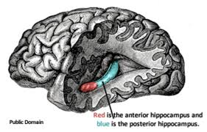
Answer the following questions:

- Maguire’s study was a quasi-experiment, what do we mean by this?
- Maguire used Magnetic Resonance Imaging (MRI), how does it work? Describe to other brain scanning techniques e.g. PET, CT, EEG.
- Read through the information on the BPS guidelines online (see pgs. 15 &16) Identify and explain at least 1 ethical issue that may have arisen in this research.

Loftus & Palmer
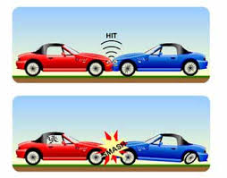
Loftus & Palmer is a very famous psychology study investigating the reliability of eyewitness testimony.

- Research Loftus and Palmer’s study and write out the aim, procedure, findings and conclusion.
- Why did Loftus decide to carry out his research?
- Loftus and Palmer’s research has been criticised for lacking in ecological validity. What do we mean by this?


TIENARI (1994) Stretch & Challenge

Tienari, P. et al (1994) The Finnish adoptive family study of schizophrenia: Implications for family research. The British Journal of Psychiatry, Vol 164(Suppl 23), Apr 1994, 20-26

Background: There is a huge debate about whether schizophrenia (a mental illness where symptoms include hallucinations & delusions) is caused biologically or whether it is caused by environmental factors (the nature-nurture debate). This study was carried out to see the extent to which schizophrenia was caused by genetics (nature). In other words, whether the cause of schizophrenia is inheriting a gene from your parents, leading to the development of the mental illness.

The Study: Tienari studied a nationwide Finnish sample of children born to schizophrenic mothers and who were put up for adoption. He then compared them with a matched group of children born to non-schizophrenic mothers who had also been put up for adoption. There were 155 children in the schizophrenic sample and 186 in the non-schizophrenic sample. The adoptive families and biological parents were investigated using interviews and psychological tests. He found that there was a much higher incidence of severe mental disorder in the children in the schizophrenic sample compared to those in the non-schizophrenic sample. However, this was only really noticeable in the families rated as ‘disturbed’.

Conclusion: Tienari concluded that this finding provided clear support for the genetic hypothesis of schizophrenia.
TASK:
Read through the study again and think of why we may not agree with Tienari’s conclusion that schizophrenia is down to genetics only. Try and think of at least 2 points and explain these clearly.

